# Brainstorm

**TIP**

Add customizable tags to stickynotes to make it easier to find,browse, organize, andcategorize important ideas asthemeswithinyourmural.

**TIP**

You can select a sticky noteand hit the pencil [switch tosketch]icontostartdrawing!

**TIP**

Participants can use theircursors to point at wheresticky notes shouldgo onthe grid. The facilitator canconfirm the spot by usingthe laser pointer holding the**Hkey**onthekeyboard.

## Beforeyoucollaborate

#### Alittlebitofpreparationgoesalongwaywith this session. Here’s what you needtodotogetgoing.

##### 10minutes

**1**

## Defineyourproblemstatement

#### What problem are you trying to solve? Frame yourproblemasaHowMightWestatement.Thiswillbethefocusofyourbrainstorm.

##### 5minutes

**2**

## Brainstorm

#### Writedownanyideasthatcometomindthataddressyourproblemstatement.

##### 10minutes

**3**

## Groupideas

#### Taketurnssharingyourideaswhileclusteringsimilarorrelatednotesasyougo.Onceallsticky notes have been grouped, give each cluster a sentence-like label. If a cluster isbiggerthansixstickynotes,tryandseeifyouandbreakitupintosmallersub-groups.

##### 20 minutes

**4**

## Prioritize

#### Yourteamshouldallbeonthesamepageaboutwhat'simportantmoving forward. Place your ideas on this grid to determine whichideasareimportantandwhicharefeasible.

**20 minutes**

## Afteryoucollaborate

Youcanexportthemuralasanimageorpdftosharewithmembersofyourcompanywhomightfindithelpful.

**Quickadd-ons**

# &ideaprioritization

Use this template in your ownbrainstormingsessionssoyourteamcan unleash their imagination andstart shaping concepts even if you'renotsittinginthesameroom.

**10minutes**toprepare

**1hour**tocollaborate

**2-8people**recommended

**A Teamgathering**

Definewhoshouldparticipateinthesessionandsendaninvite.Sharerelevantinformationorpre-workahead.

**B Setthegoal**

Think aboutthe problemyou'llbe focusingonsolving inthebrainstormingsession.

###### C Learnhowtousethefacilitationtools

Use the Facilitation Superpowersto run ahappy andproductivesession.

###### [Openarticle](https://support.mural.co/en/articles/2113740-facilitation-superpowers)

**PROBLEM**

Whether you're amultinational corporationseeking to expand into newmarkets, a governmentagencyformulating

international policies, anacademic delving into cross-border studies, or simply atraveler planning your nextadventure, access tocomprehensive andinsightful country data is apowerfultool.

**Keyrulesofbrainstorming**

Torunansmoothandproductivesession

###### Anusorna.K

The dataset being used is **awealthofinformationaboutallcountriesworldwide,coveringawide range of indicators andattributes**. It encompassesdemographicstatistics,economic indicators,environmental factors,healthcaremetrics,educationstatistics,andmuchmore.

Arunkumar.G

CountryData **offers political,economic,financial,andsocialdata for over 140 countries**, inmostcasesbackto1984.

CountryData is also the onlysourceforcurrentandhistoricalrisk ratings developed from theInternational Country Risk Guideand Political Risk Services ratingsystems conductedbyPRSGroup

###### Aravinth.S

**The Global Overview (GO)providesageneralreviewofthe groundwater conditions percountry. It contains a set ofaggregated groundwater-related attributes for eachcountryandenablescomparison of groundwatercharacteristics betweencountries and identification ofglobalpatterns**

###### ArnikaK

Thedatabasecontainsmorethan 70 attributes, divided intovariouscategories(groundwaterdevelopment, management,agricultureandeconomics,etc.).

To compile these data sets,IGRACmadeuseofpubliclyavailable information found onthe internet, in publications,reportsandmaps

A collection of the statisticalabstractsofvariouscountries,bothindividuallysearchableandcrosssearchable. These statisticalabstractsaregenerallyissuedbythenationalstatisticalofficesofforeigngovernmentsandcontaincountry-level data not easily foundelsewhere. Global and regionalstatistical compendia issued byinternational organizations andresearchfirmsarealsoincluded

**The table providescomprehensivedataonvariousattributesof195countries,suchas**

**+**

PortaltoUCSD-subscribedEIU content. Includessearchable online archive(1996-)andfeedofEconomistIntelligence Unit (EIU) globalcountry publications. Strongoncurrentpolitical,economic,and business affairsworldwide.

**A Sharethemural**

**Shareaviewlink**tothemuralwithstakeholderstokeepthemintheloopabouttheoutcomesofthesession.

**B Exportthemural**

Export a copy of the mural as a PNG or PDF to attach toemails,includeinslides,orsaveinyourdrive.

### Keepmovingforward

###### Strategyblueprint

Define the components of a new idea orstrategy.

###### [Openthe template](https://app.mural.co/template/e95f612a-f72a-4772-bc48-545aaa04e0c9/984865a6-0a96-4472-a48d-47639307b3ca)

**Customerexperiencejourneymap**

Stay intopic.

Deferjudgment.

Encouragewildideas.

Listentoothers.

**population, GDP, educationenrollment, healthcare, andmore**,makingitessentialfor

### Importance

If each of thesetaskscouldget

Understand customer needs, motivations, andobstaclesforanexperience.

###### [Openthe template](https://app.mural.co/template/b7114010-3a67-4d63-a51d-6f2cedc9633f/c1b465ab-57af-4624-8faf-ebb312edc0eb)

Goforvolume. Ifpossible,bevisual.

analyzingandcomparing

globalcountryinformation.

done without anydifficulty or cost,which would havethemostpositiveimpact?

Provides easy access to statisticaldata.DataisdownloadableinExceland CSV, and shapefiles whenmultiple geographies are covered.

Sources include: Bombay StockExchange, British Bankers'Association,ChicagoBoardOptions,Exchange, China Data Center, D&B(Dun & Bradstreet), Dave Leip's Atlasof US Presidential Elections, DefenseManpower Data Center, DeutscheBörse Group, Dow Jones, EasyAnalyticSoftwareInc.

###### Strengths,weaknesses,opportunities&threats

Identify strengths, weaknesses, opportunities,andthreats(SWOT)todevelopaplan.

|  |  |
| --- | --- |
|  |  |
|  |  |

###### [Openthe template](https://app.mural.co/template/6a062671-89ee-4b76-9409-2603d8b098be/ca270343-1d54-4952-9d8c-fbc303ffd0f2)

**[Sharetemplatefeedback](https://muralco.typeform.com/to/CiqaHVat?typeform-source=app.mural.co)**

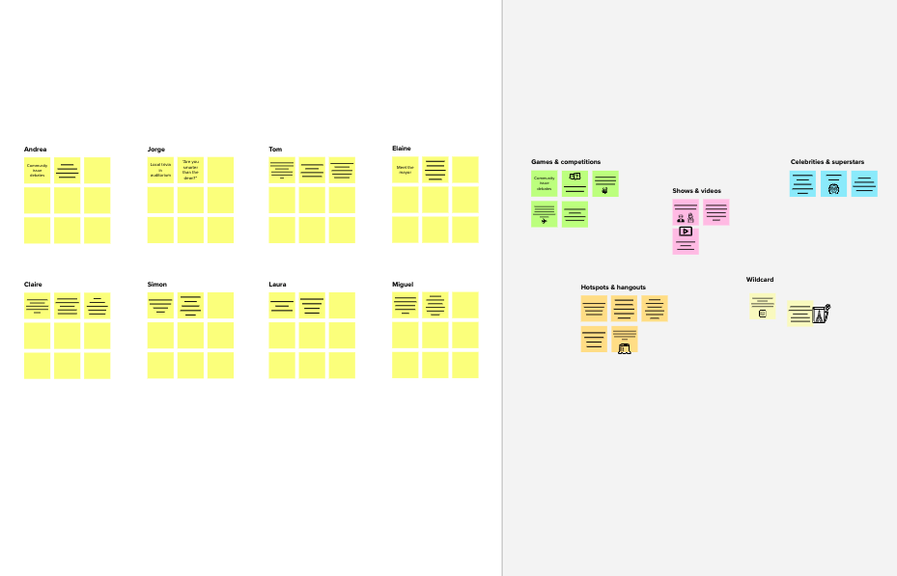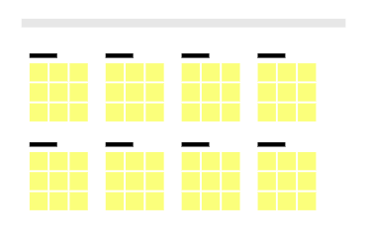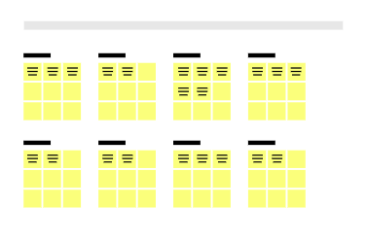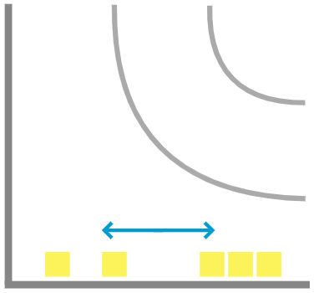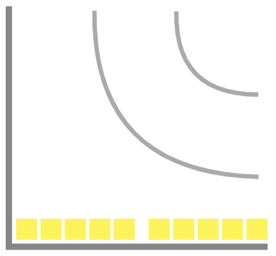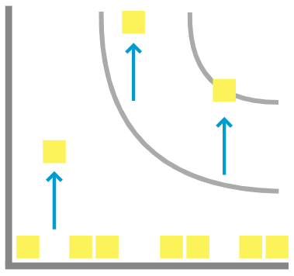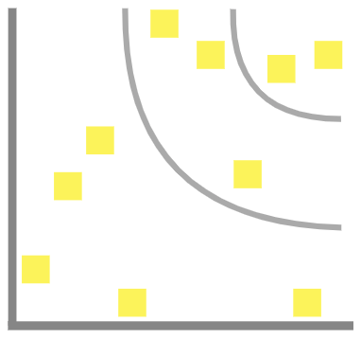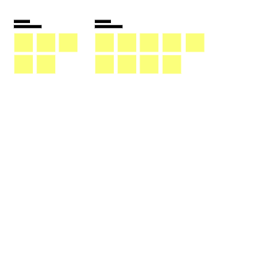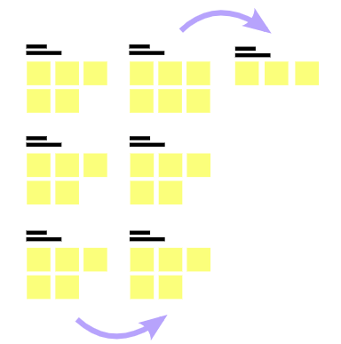

**Template**

**-**

**- Feasibility +**

Regardlessoftheirimportance,whichtasksaremorefeasiblethanothers?(Cost,time,effort,complexity,etc.)

**Need someinspiration?**

See a finished versionof this template tokickstartyourwork.

**[Openexample](https://app.mural.co/template/e5a93b7b-49f2-48c9-afd7-a635d860eba6/93f1b98d-b2d2-4695-8e85-7e9c0d2fd9b9)**